**Examination System.**

**Objective:**

To create an online examination module, which can calculate the result also.

**Users of System:**

Students only.

**Functional Requirement of user:**

Command Prompt , Notepad.

**Tools Used:**

Notepad , command Prompt , JDK (version 12).

**How Project Works:**

In this project it a type of module which you can use for online examination. In this there are 10 questions will appear and each and every question allotted 1 mark. At the end it can calculate your result and show you that how many answers are right on the basis of marks . We can also apply bookmarks for the questions, functionality of bookmarks that we can attempt that question after some another questions which present on the next side of that bookmarked question.

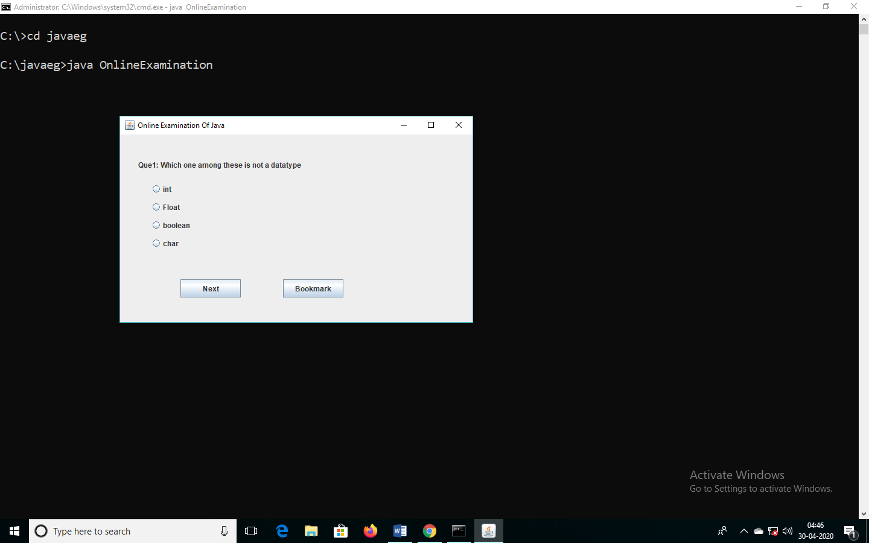

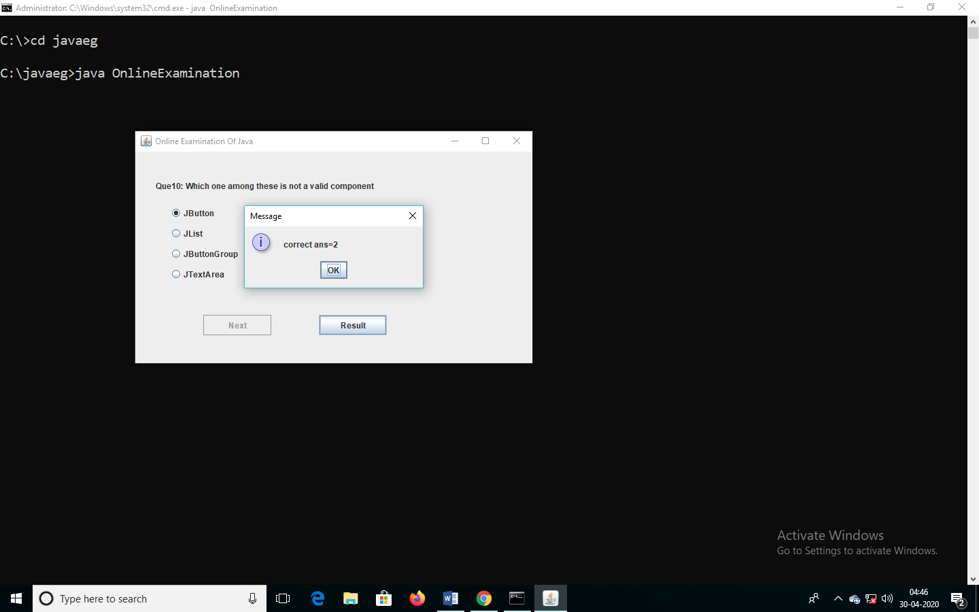

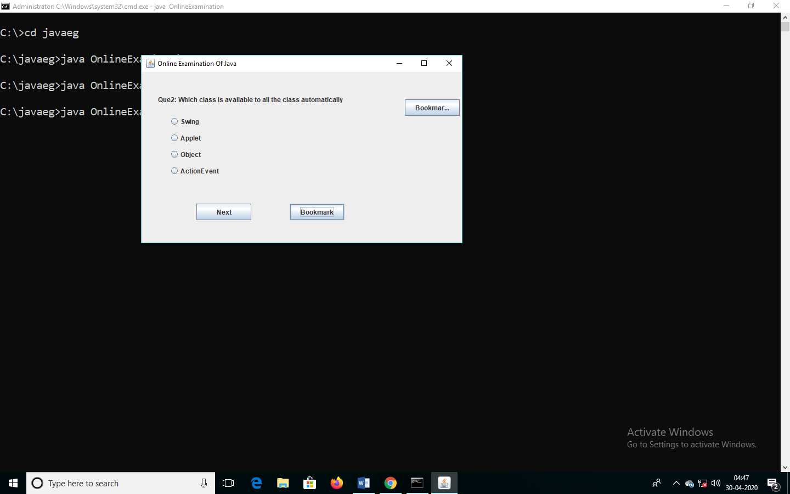

**Activity Diagram:**

Take Examination.

Validate Answers of attempting questions.

Show Result.

**Class Diagram:**

Initialising the variables like JButtons , radio buttons tec.

At the end all marks will calculated and show the result.

Nothing.

False

Marks increment by 1.

True

If answer is true than marks increment by one.

Check the current question and update the details.

**Data Flow Diagram:**

Take input from radio button.

Validate using check Function

n.

Increase the value.

At the end all data will calculated.

Then final Output will represent.